**Virtual Memory in Operating System**

The size of virtual storage is limited by the addressing scheme of the computer system and the amount of secondary memory available not by the actual number of main storage locations.

1. All memory references within a process are logical addresses that are dynamically translated into [physical addresses](https://www.geeksforgeeks.org/logical-and-physical-address-in-operating-system/) at run time. This means that a process can be swapped in and out of the main memory such that it occupies different places in the main memory at different times during the course of execution.
2. A process may be broken into a number of pieces and these pieces need not be continuously located in the [main memory](https://www.geeksforgeeks.org/computer-memory/) during execution. The combination of dynamic run-time address translation and the use of a page or segment table permits this.

If these characteristics are present then, it is not necessary that all the pages or segments are present in the main memory during execution. This means that the required pages need to be loaded into memory whenever required. Virtual memory is implemented using Demand Paging or Demand [Segmentation](https://www.geeksforgeeks.org/segmentation-in-operating-system/).

1. If the CPU tries to refer to a page that is currently not available in the main memory, it generates an interrupt indicating a memory access fault.
2. The OS puts the interrupted process in a blocking state. For the execution to proceed the OS must bring the required page into the memory.
3. The OS will search for the required page in the logical address space.
4. The required page will be brought from logical address space to physical address space. The page replacement algorithms are used for the decision-making of replacing the page in physical address space.
5. The page table will be updated accordingly.
6. The signal will be sent to the CPU to continue the program execution and it will place the process back into the ready state.

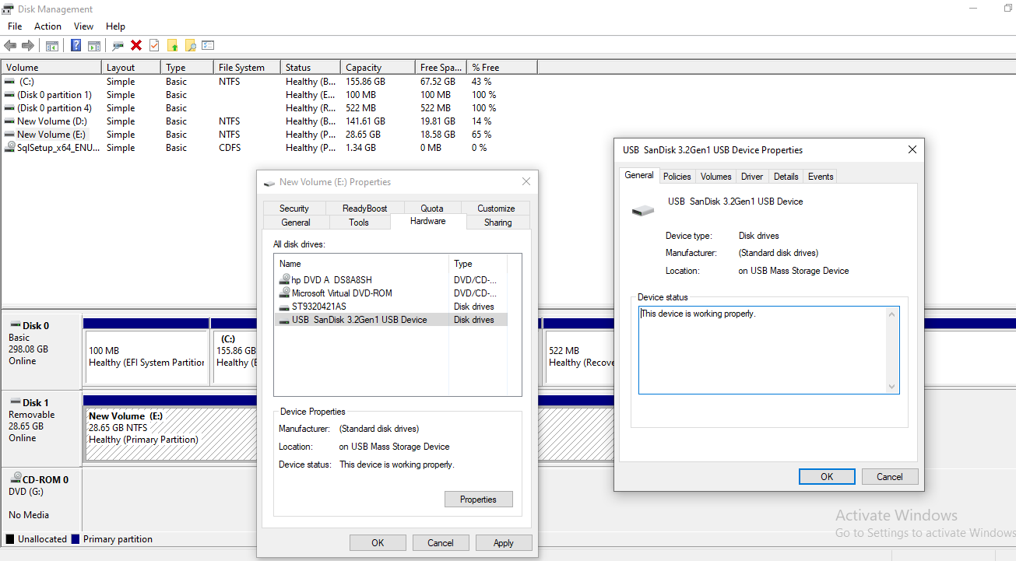

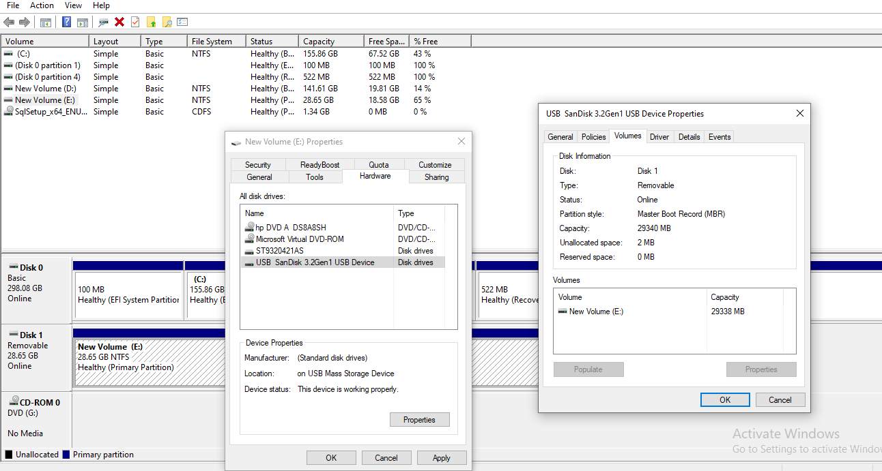

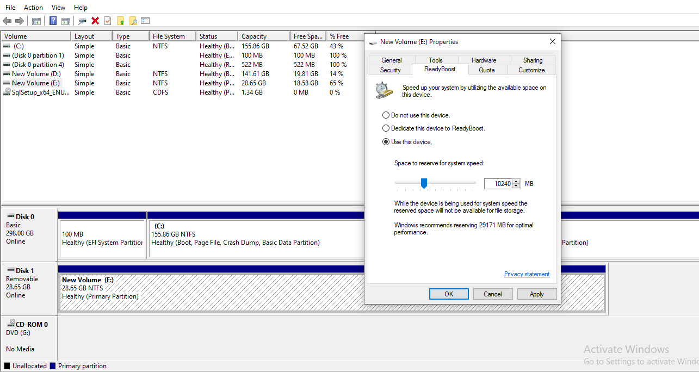

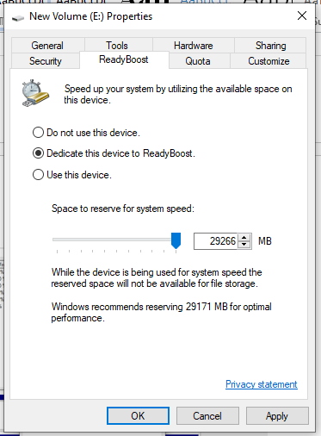

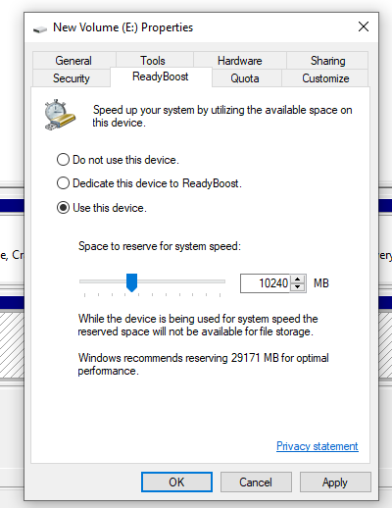

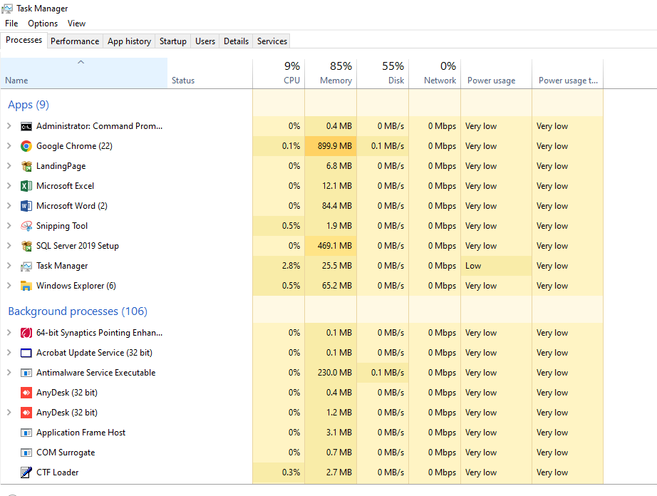

After remove pen drive disk utilization is high

